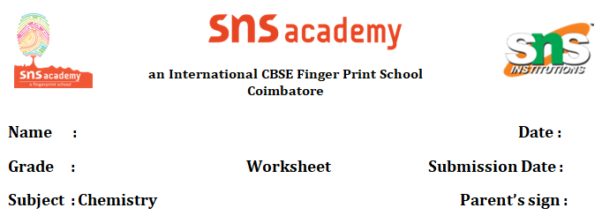

**A TRULY BEAUTIFUL MIND 07.08.25**

**GIVE SHORT ANSWERS**

1. **When and where was Albert Einstein born?**

Albert Einstein was born on 14 March 1879 in the German city of Ulm.

**2. What did Einstein's mother initially think about him?**

His mother thought Albert was a "freak" because his head seemed much too large.

**3. What did Einstein's playmates call him when he was a child?**

His playmates called him "Brother Boring" because he did not know what to do with other children.

**4. What instrument did Einstein learn to play, and what kind of musician did he become?** Einstein began learning to play the violin at age six and later became a gifted amateur violinist, maintaining this skill throughout his life.

**5. Where did Einstein get a job after being unemployed for a while?**

He finally secured a job in 1902 as a technical expert in the patent office in Bern.

**6. What was one of the ground-breaking papers Einstein published in 1905?**

One of the famous papers of 1905 was Einstein’s Special Theory of Relativity.

**GIVE LONG ANSWERS**

1. **Describe Einstein's experience in high school in Munich and why he left.**

Albert Einstein attended high school in Munich, where his family had moved when he was 15 months old. Despite his later reputation, he scored good marks in almost every subject. However, Einstein hated the school’s "regimentation" (order or discipline taken to an extreme) and often clashed with his teachers. This strict environment made him feel "stifled" (unable to breathe or suffocated). Due to this feeling of suffocation, at the age of 15, Einstein left the school for good. Following this, he managed to get his wish to continue his education in German-speaking Switzerland, in a city described as more liberal than Munich.

1. **How did Einstein react to the atomic bombings of Hiroshima and Nagasaki, and what did he do afterward?**

When the atomic bomb was developed by the Americans in a secret project and subsequently dropped on the Japanese cities of Hiroshima and Nagasaki in August 1945, Einstein was "deeply shaken by the extent of the destruction". In response to this devastation, he wrote a public "missive" (letter) to the United Nations. In this letter, he proposed the formation of a world government, though unlike his earlier letter to President Roosevelt, this one "made no impact". Over the next decade, Einstein became increasingly involved in politics, actively "agitating for an end to the arms buildup" (campaigning against it) and using his popularity to campaign for peace and democracy. This demonstrates his shift from purely scientific pursuits to a dedicated role as a humanitarian and advocate for global peace.